ASSIGNMENT 1

TEAM ID: PNT2022TMID04331

UPLOADING DATASET:

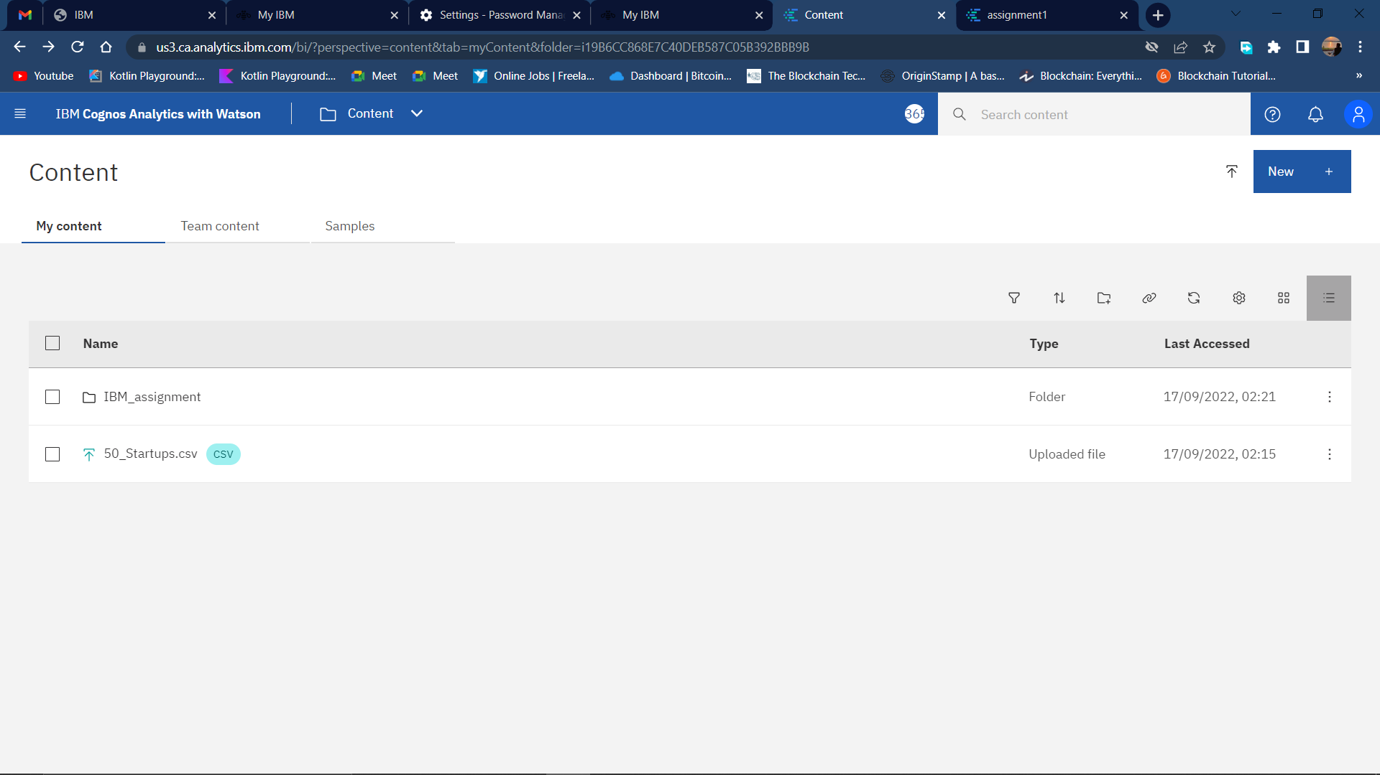

<https://us3.ca.analytics.ibm.com/bi/?perspective=content&tab=myContent&folder=i19B6CC868E7C40DEB587C05B392BBB9B>

BAR GRAPH:

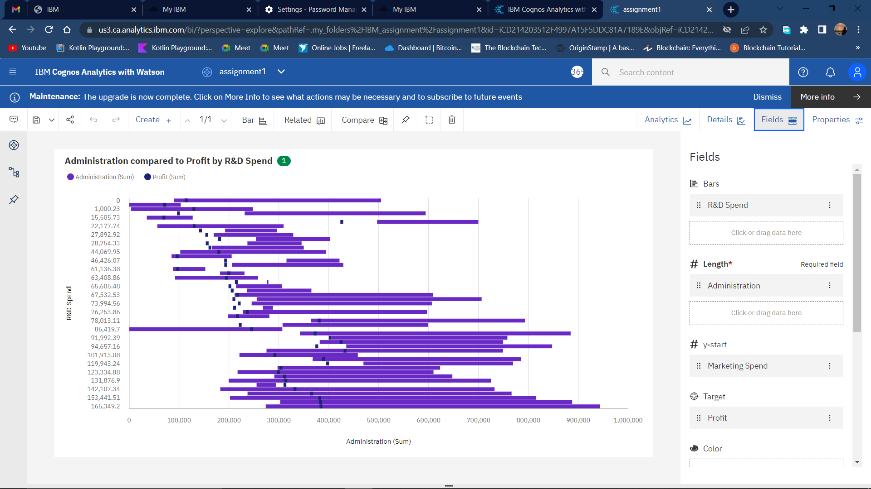

<https://us3.ca.analytics.ibm.com/bi/?perspective=explore&pathRef=.my_folders%2FIBM_assignment%2Fassignment1&subView=model000001834a4e32ed_00000004>

COLUMN CHART:

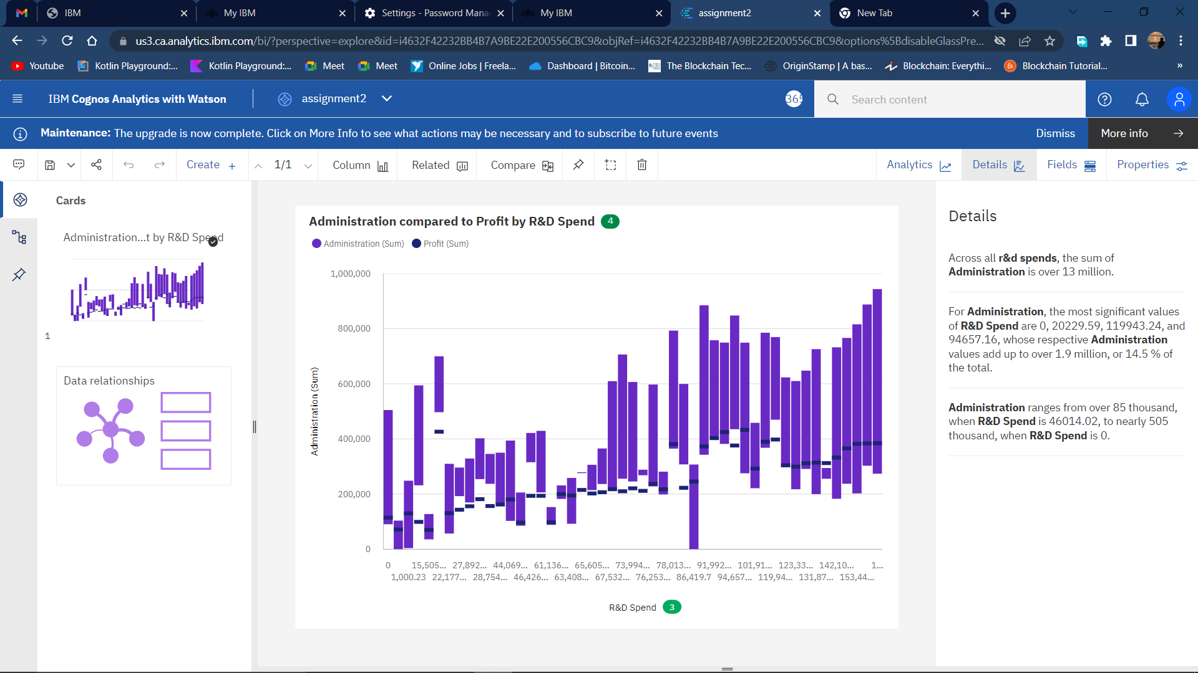

<https://us3.ca.analytics.ibm.com/bi/?perspective=explore&pathRef=.my_folders%2FIBM_assignment%2Fassignment2&subView=model000001834a6219bb_00000003>

BULLET GRAPH:

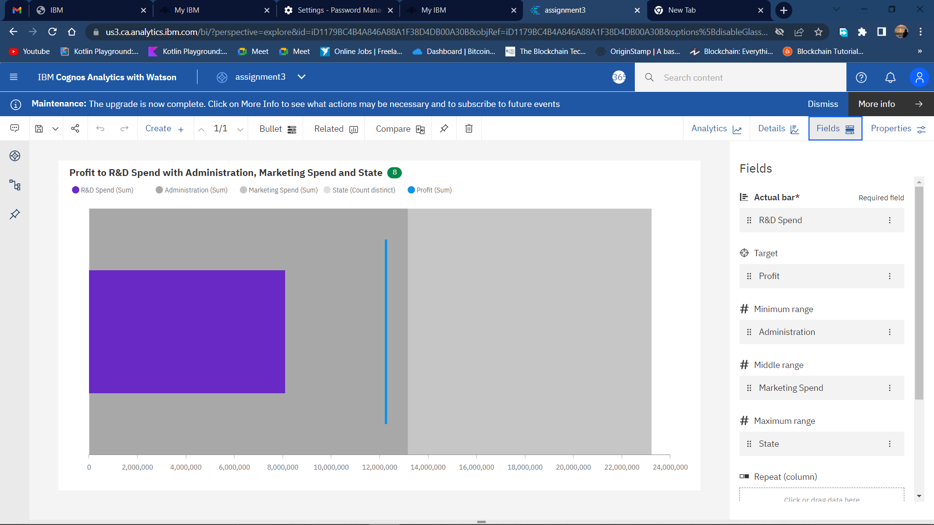

<https://us3.ca.analytics.ibm.com/bi/?perspective=explore&pathRef=.my_folders%2FIBM_assignment%2Fassignment3&subView=model000001834a6475d5_00000000>

RADAR:

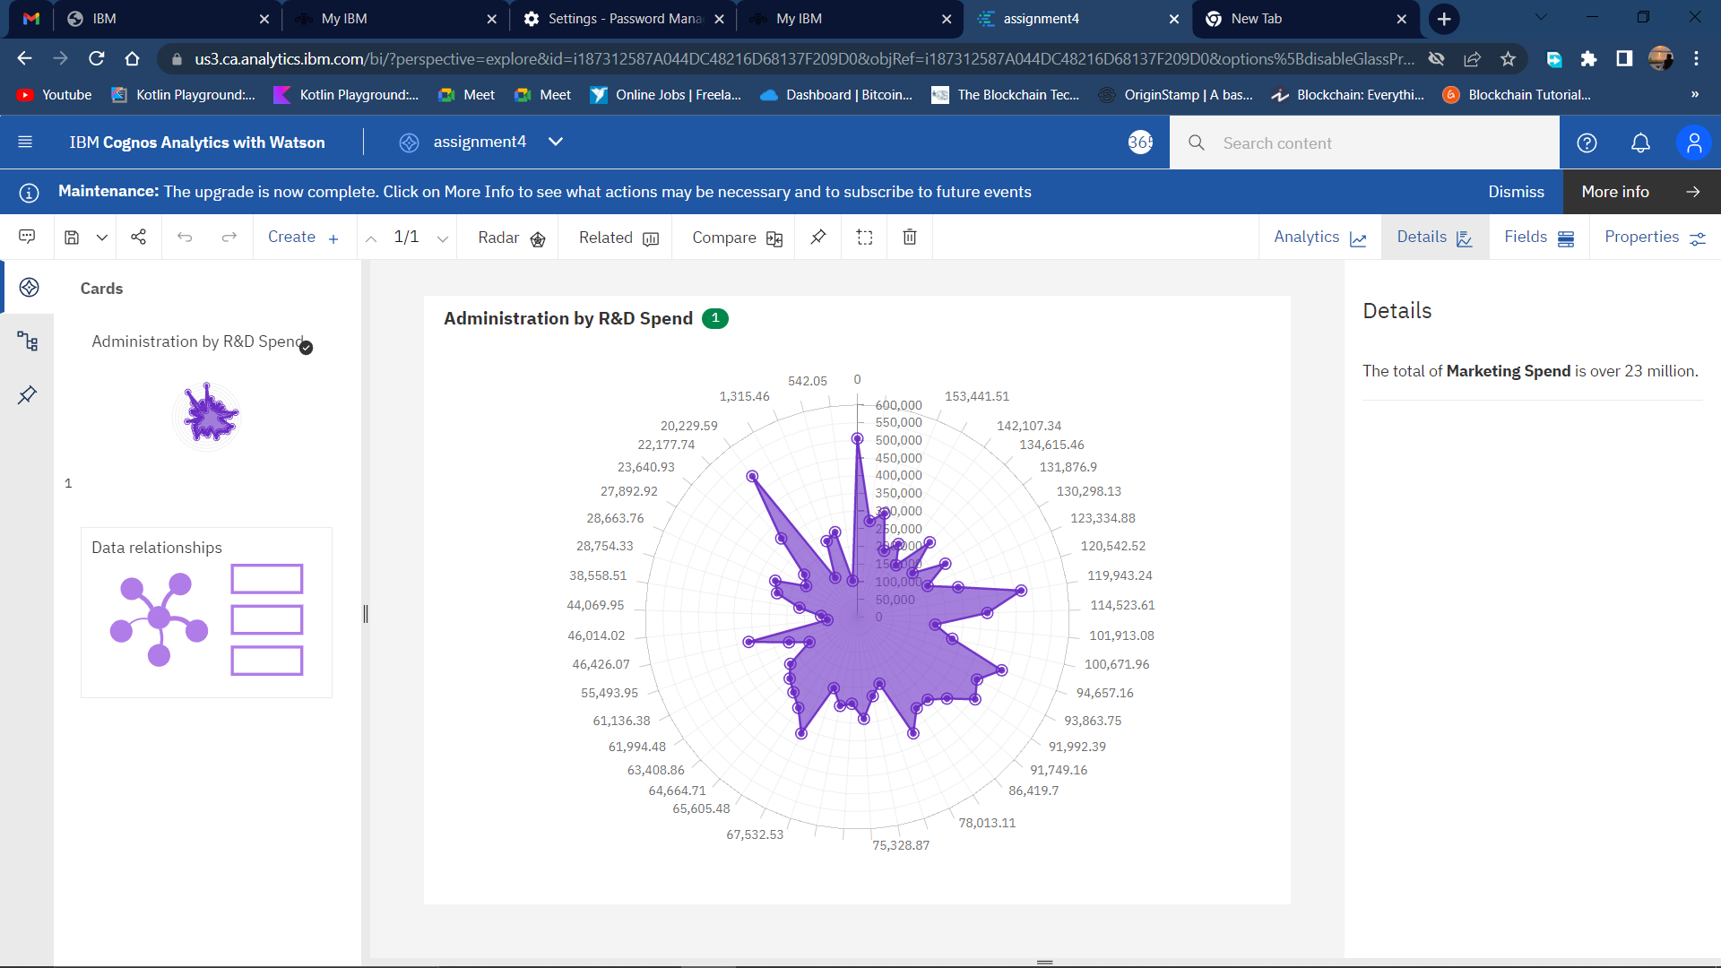

<https://us3.ca.analytics.ibm.com/bi/?perspective=explore&pathRef=.my_folders%2FIBM_assignment%2Fassignment4&subView=model000001834a668625_00000000>

BUBBLE:

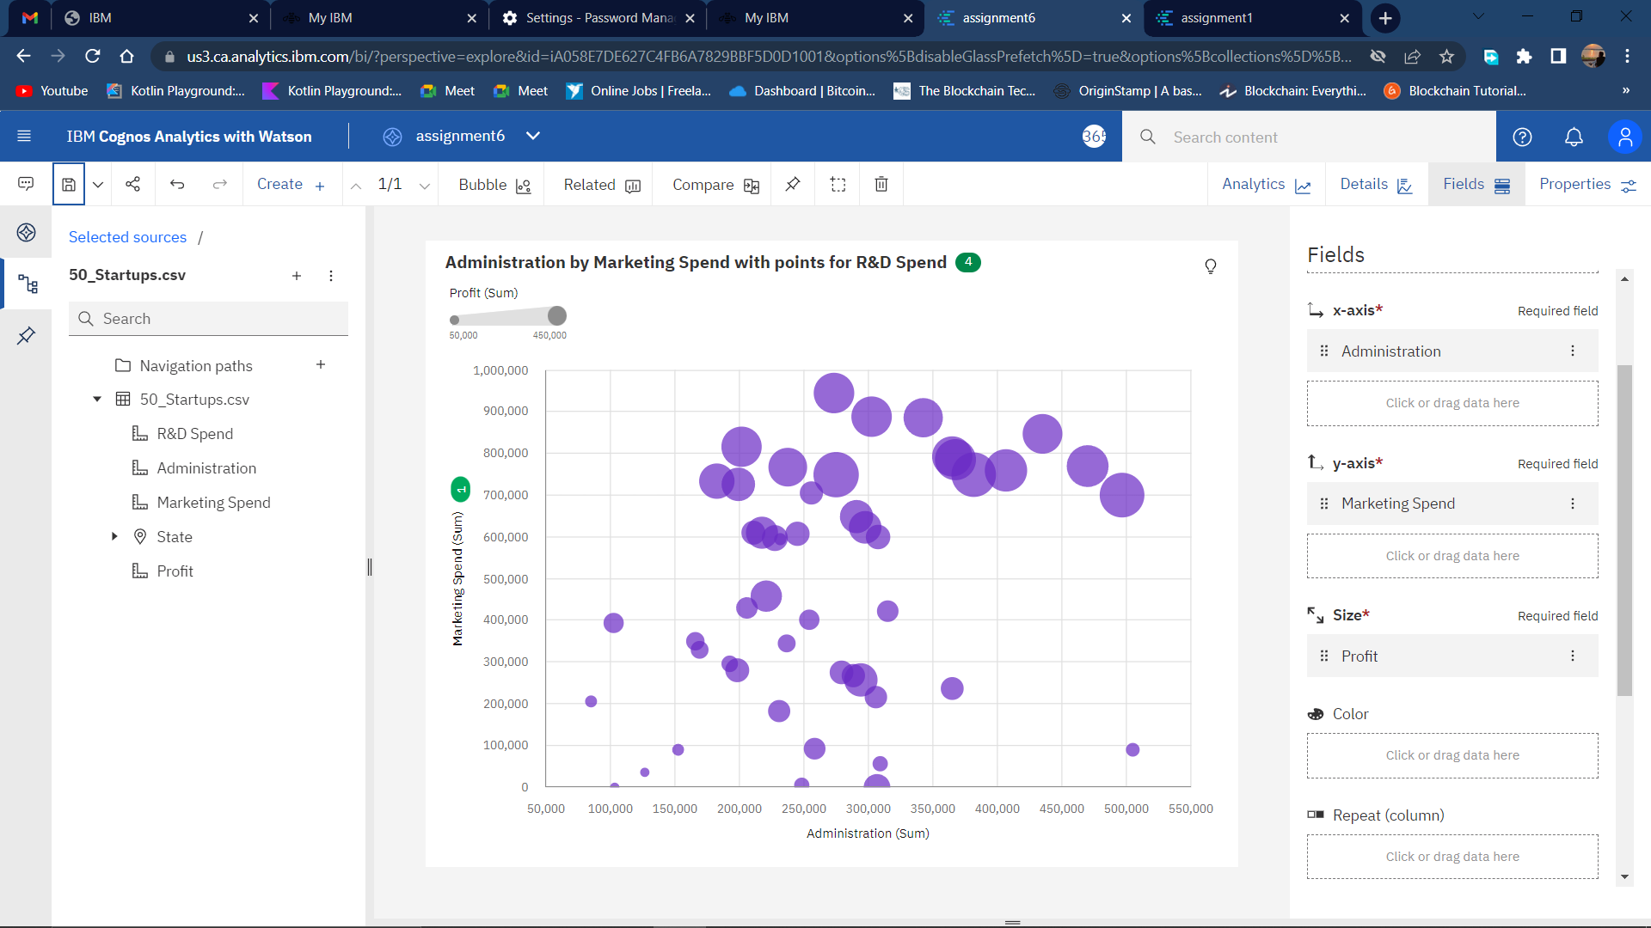

<https://us3.ca.analytics.ibm.com/bi/?perspective=explore&pathRef=.my_folders%2FIBM_assignment%2Fassignment6&subView=model000001834a6e29d3_00000000>

PIE CHART :

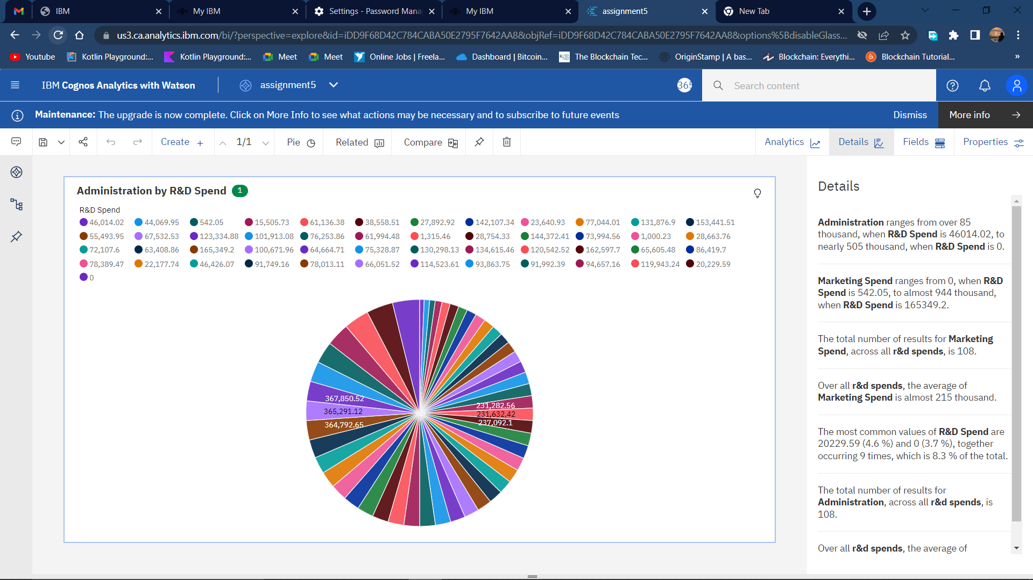

<https://us3.ca.analytics.ibm.com/bi/?perspective=explore&pathRef=.my_folders%2FIBM_assignment%2Fassignment5&subView=model000001834a68a258_00000000>